**USER DATABASE**

Application which takes name and email address and displays all the names and email addresses on the root window

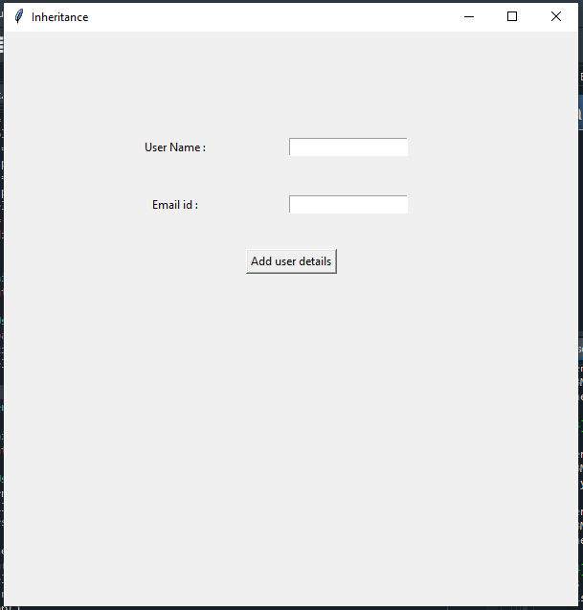

When added the user name , email address and clicked on “Add user details” then the user details are added into the dictionary and the dictionary content is displayed on the root window